PROJECT 3 REPORT: SQL DATA ANALYSIS
Name: Favour Secondus
Batch: July, 2026.
PROBLEM STATEMENT
To analyze customer order data using SQL to identify top-performing products, seasonal revenue trends, order status distribution, and high-value orders.
METHODOLOGY
Data was imported into PostgreSQL from a cleaned CSV dataset containing 1200 orders (January 2023 to June 2025) and 14 columns. SQL queries were written using:
SELECT, FROM, WHERE, GROUP BY, HAVING, ORDER BY, LIMIT, Aggregate functions: SUM(), AVG(), COUNT(), and EXTRACT() for month-based analysis.
Outliers- orders above the already calculated upper bound (3333.53) were identified as high-value orders.

KEY FINDINGS
Revenue & Orders
METRIC | RESULT
Total Revenue | 1,264,762
Average Order Value | 1,053.97
Total Orders | 1,200
Top Product | Chair (195,620)
Highest Revenue Month | June (170,616)
Highest Realized Revenue Month (delivered only) | June (38,801)
Least Revenue Month | September (69,322)
Least Realized Revenue Month (delivered only) | February (7,592)
Revenue Gap (June) | 131,815 (June revenue not delivered)
Most Common Order Status | Cancelled (250 orders; all five statuses are 231 to 250)
Top Delivered Product | Laptop (40,714)
High-Value Orders (above 3,333.53) | 8 orders (8 different customers)

SQL QUERIES USED
Query 1: Filtered Orders (WHERE) Orders above $1000
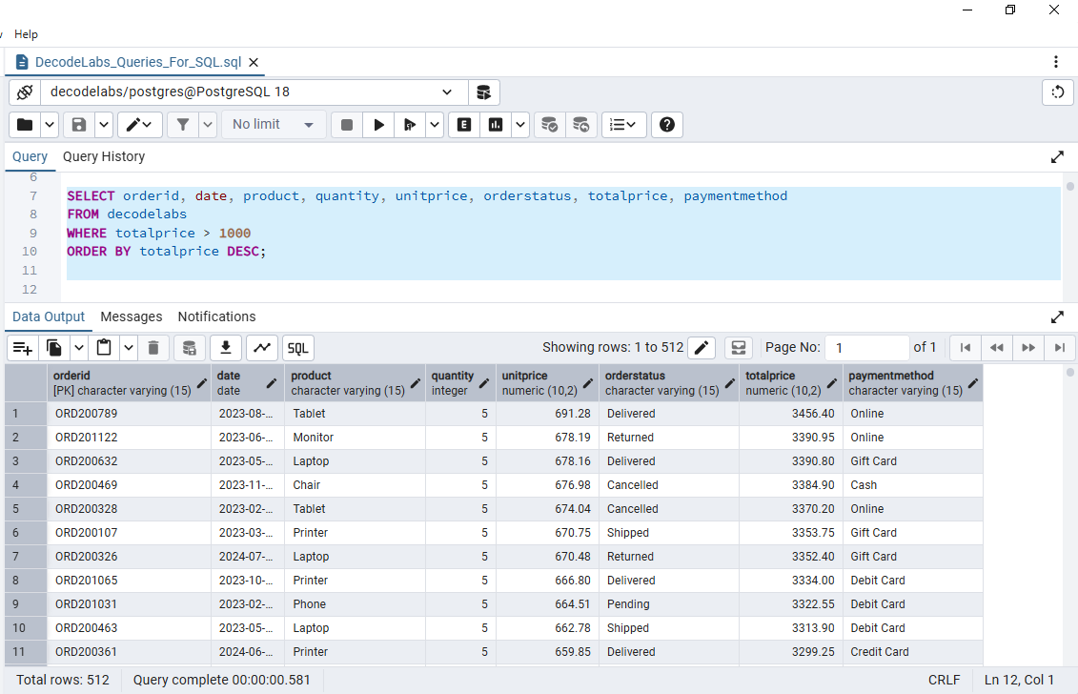
Query 2: Revenue generated by each Product (GROUP BY + SUM)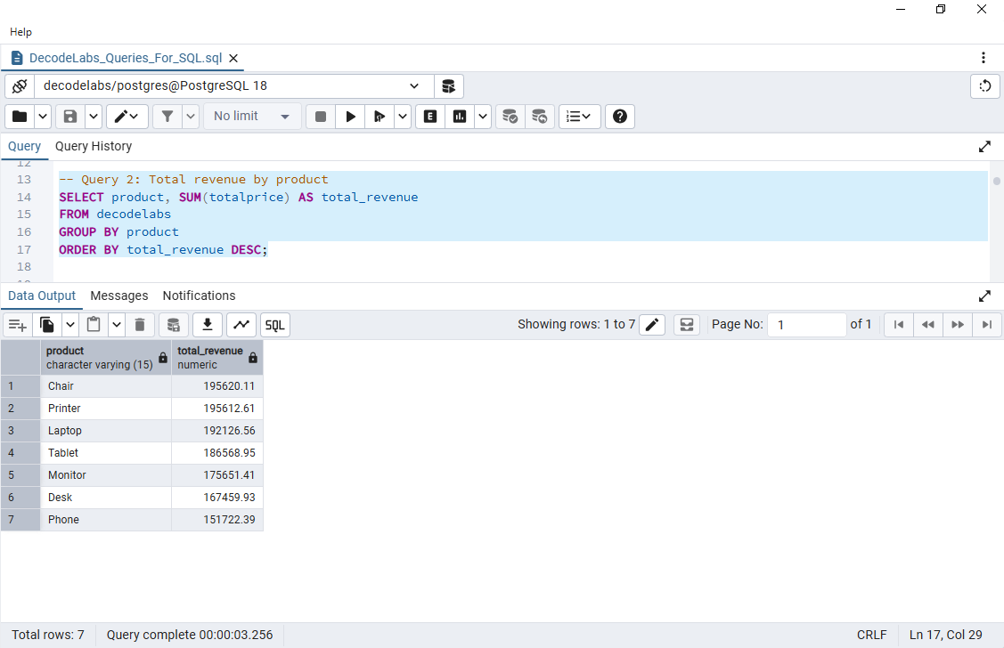
Query 3: Revenue by Month, all years combined (EXTRACT + GROUP BY)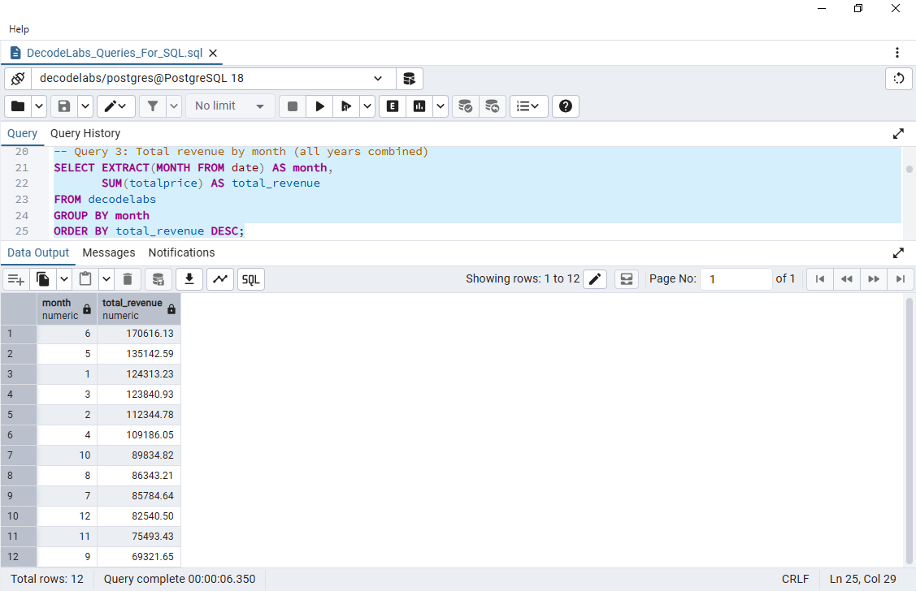
Query 4: Realized Revenue by Month, all years combined, for Delivered Products (EXTRACT + GROUP BY + WHERE)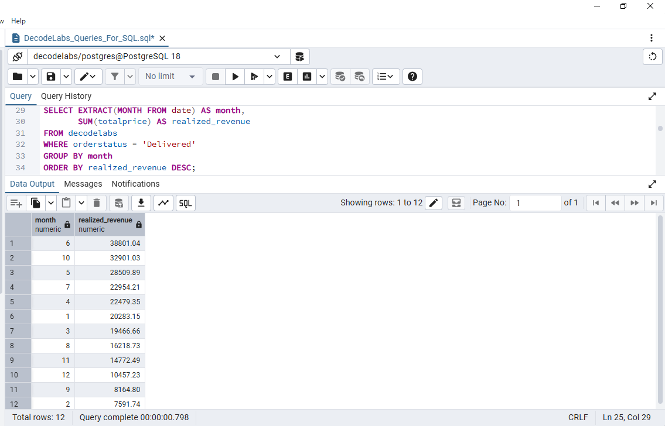
Query 5: Month with the Least Revenue (EXTRACT + GROUP BY + LIMIT 5)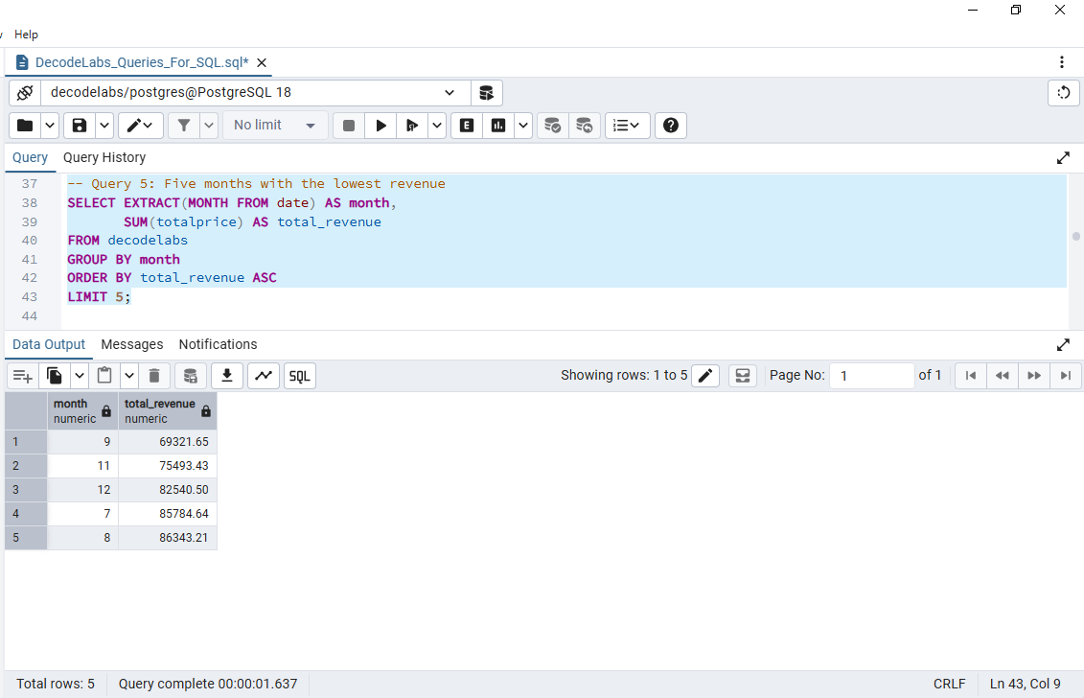

Query 6: Order Status Counts (GROUP BY + COUNT)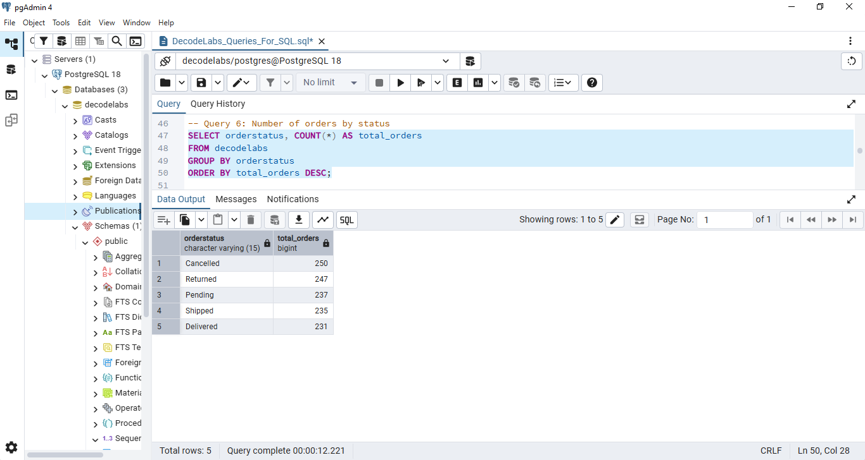
Query 7: Aggregations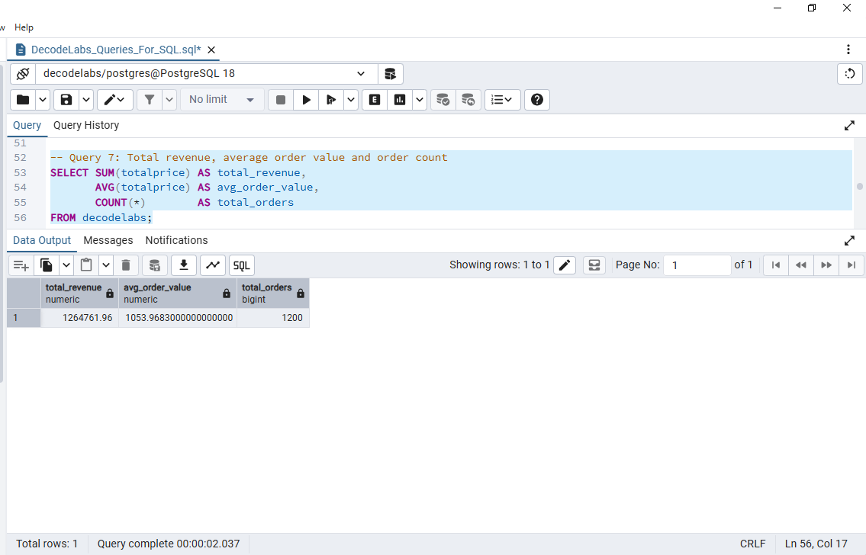

Query 8: Products above 150,000 (HAVING)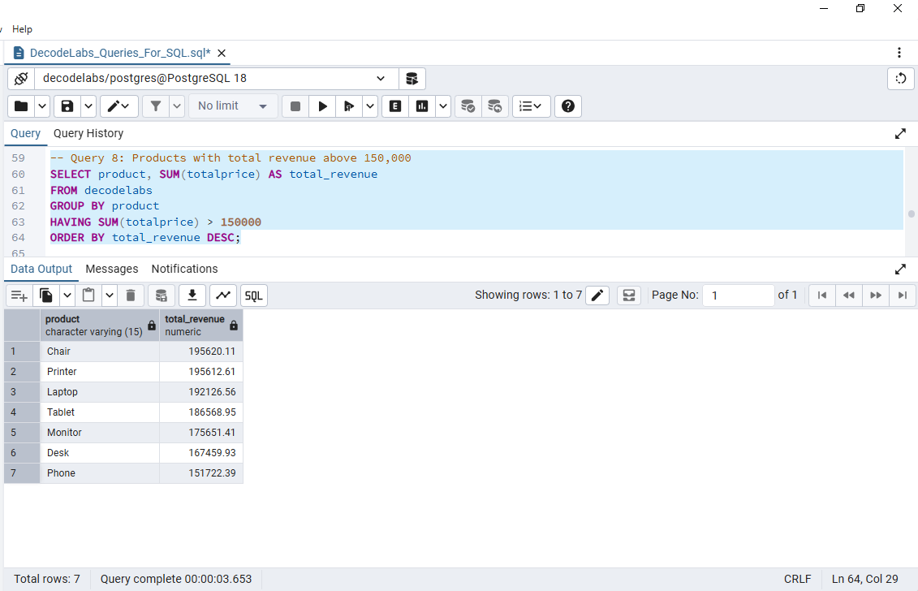Query 9: Top 3 Delivered products (WHERE + LIMIT)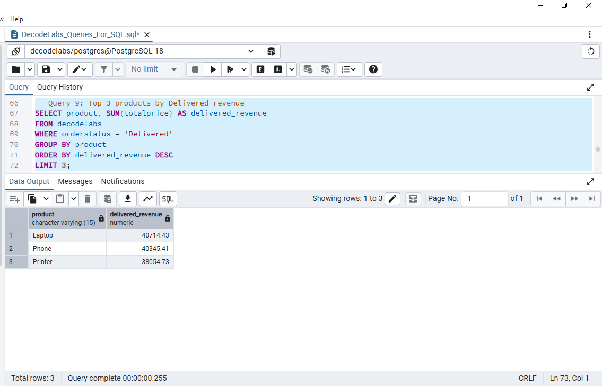

Query 10: Outliers (VIP Customers)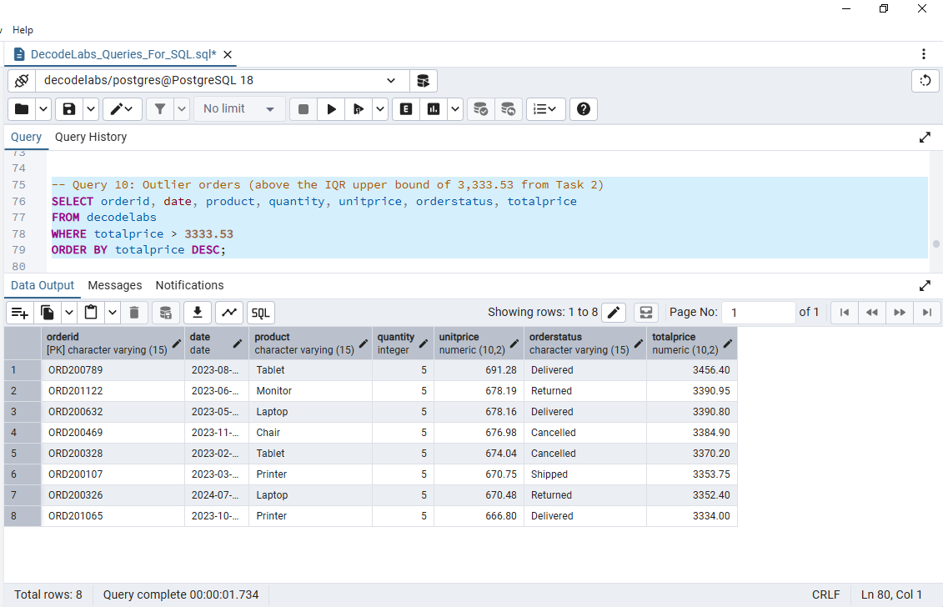Query 11: Month with the Most Cancellations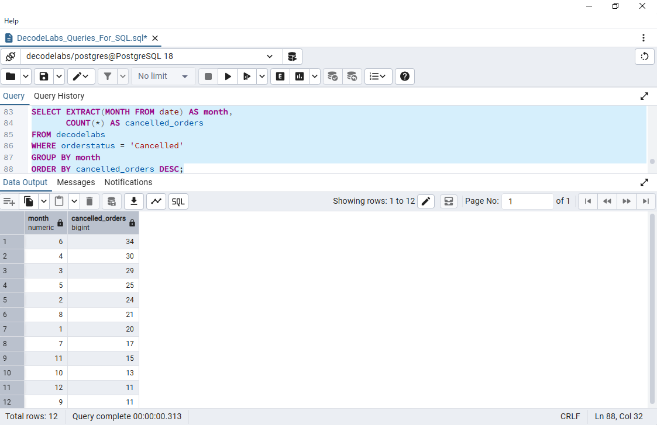
Query 12: Revenue by Month and year 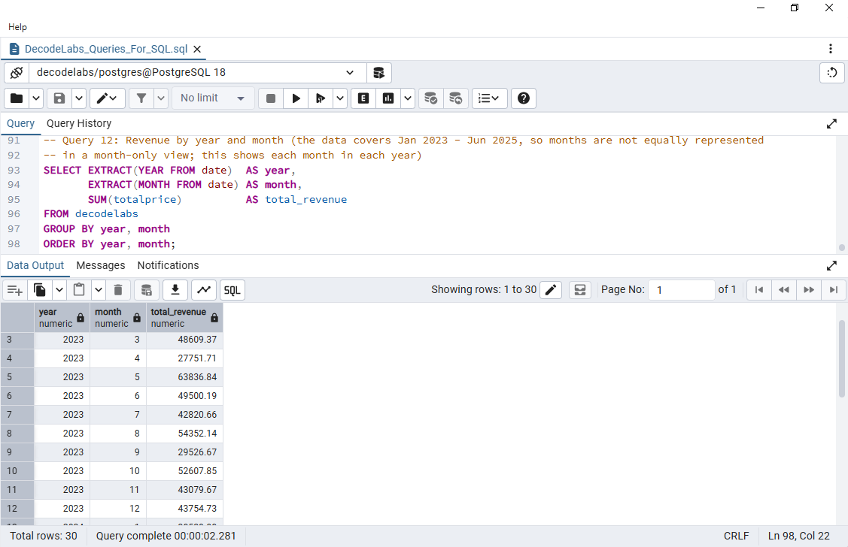
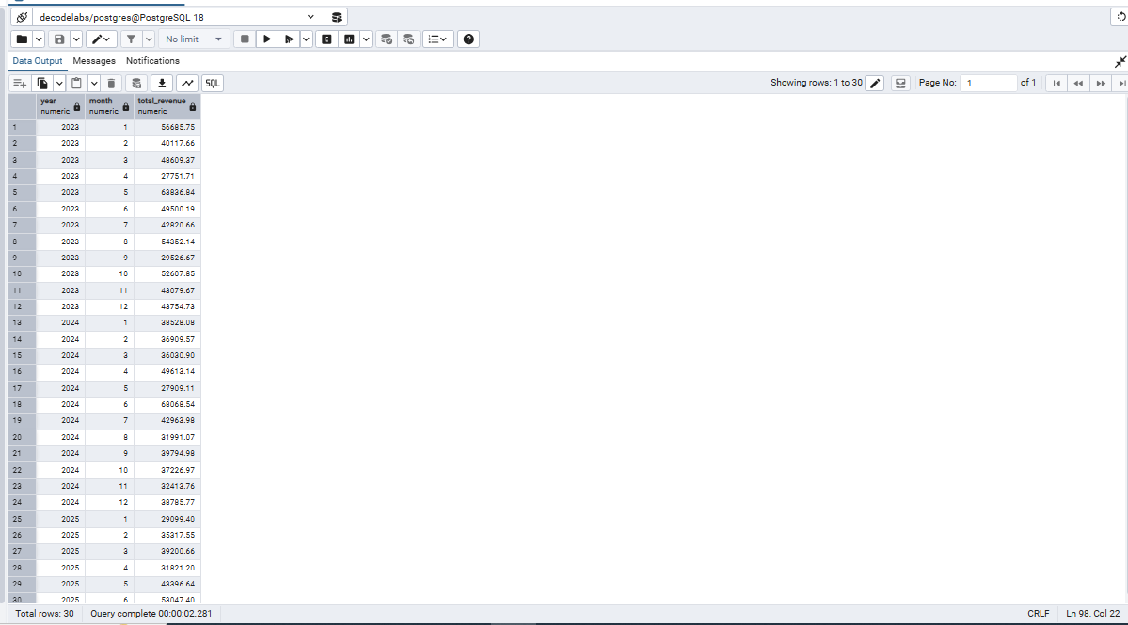

RECOMMENDATIONS
- Prioritize Top-Performing Products: Chair (195,620), Printer (195,613), Laptop (192,127), and Tablet (186,569) generate the highest revenue (Chair and Printer are almost tied). These products should be prioritized in marketing campaigns, inventory planning, and sales promotions.
- Investigate High Cancellation and Return Rates: Only 231 of the 1,200 orders (19.2%) were delivered, while 497 (41.4%) were cancelled or returned. Cancelled is the most common status at 250 orders, but all five statuses are close (231 to 250 each), so the issue is the whole fulfilment process and not one status. A root cause analysis is recommended to identify whether cancellations are driven by stock unavailability, delivery delays, pricing dissatisfaction, or customer behavior patterns.
- Optimize Marketing for Slow Months: September, November, and December are the 3 least performing revenue months across all orders. For delivered orders only, February is the weakest month (7,592). Seasonal promotions, targeted email campaigns, and discount strategies should be deployed during slow months to maintain consistent revenue throughout the year. October is the second-highest month for realized revenue. Identify what worked in June and October and replicate in these months.
- Strengthen Delivered Product Strategy: Laptop is the top revenue generating product among delivered orders (40,714), followed closely by Phone (40,345). Ensuring consistent stock availability, product quality, and fast delivery for Laptops can further boost customer satisfaction and revenue.
- June drives the highest overall revenue (170,616) and also has the most cancelled orders (34), but it is also the busiest month (147 orders) and its cancellation rate (23.1%) is only a little above the overall rate (20.8%). The bigger issue is that only 22.7% of June revenue (38,801) was delivered. Inventory, shipping, and customer support capacity should be reviewed for peak months.

LIMITATIONS
• Months are pooled across years: the data runs from January 2023 to June 2025, so January to June include three years while July to December include only two. Query 12 shows each month by year. On a like-for-like basis June is still the highest month and September the lowest, but the monthly totals in Queries 3 to 5 are not perfectly comparable.
• The delivered-only monthly ranking is less stable. Using 2023 and 2024 only, October (32,901) overtakes June (24,849) as the highest realized-revenue month.
• The 8 high-value orders come from 8 different customers and the dataset has no repeat-purchase history, so they show large orders, not loyal or VIP customers.
• Coupons, referral sources, and payment methods were not analyzed in this report.

CONCLUSION
This project successfully demonstrated the application of SQL to derive meaningful business insights from a customer order database. A total of 1200 orders were analyzed using structured queries to identify revenue drivers, seasonal patterns, top performing products, order behavior, and high-value orders. The analysis revealed three clear priorities.
Firstly, June drives the highest gross revenue but also the highest cancellation volume, (170,616 in orders versus 38,801 delivered) indicating a fulfillment gap during peak demand that requires operational review. Fixing June operations would directly improve realized revenue.
Initially, September generated the least revenue but when filtered to delivered orders only, February emerges as the weakest month, shifting the focus from cancellations to demand generation. This delivered-only ranking is less stable than the overall one, so it should be treated as a pointer for further checks.
Also, eight orders (from eight different customers) exceed the 3,333 spending threshold, a high-value segment worth watching. Repeat-purchase data would be needed to confirm any retention potential.
These findings confirm that SQL is an effective tool for isolating, verifying, and revisiting business metrics. The queries developed in this project can be reused for ongoing monitoring and adapted as new questions emerge.

